Colour TV

A television uses light to make a picture.

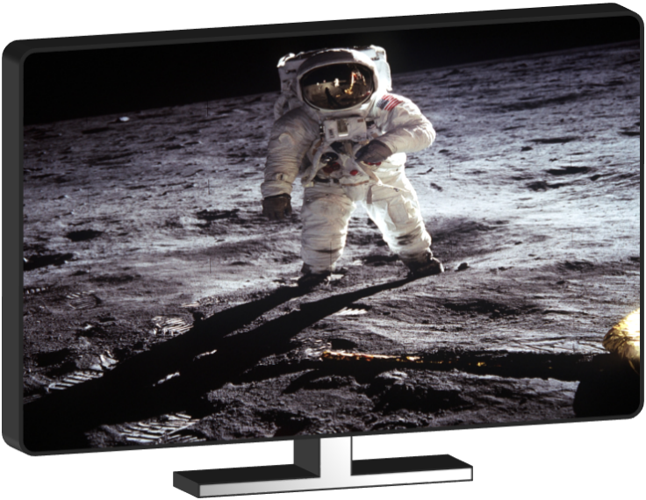

How does a TV use light to make a picture?
Which of these statements do you think are right?
For each statement, tick (✓) one column to show what you think.
Statements |  | I am sure this is right | I think this is right | I think this is wrong | I am sure this is wrong
A | A TV picture is made up of thousands of tiny coloured lights
B | All the colours on a TV are made by mixing just three colours of light
C | Mixing red and green light makes the same colour as mixing red and green paint

Physics > Big idea PSL: Sound, light and waves > Topic PSL2: How we see > Key concept PSL2.2: Seeing in colour
Diagnostic question
Colour TV

Overview
Learning focus: | Daylight and sunlight are made from all the colours of the spectrum, which together we see as ‘white light’.
Observable learning outcome: | Give an example of how coloured lights mix to make light of another colour.
Question type: | Confidence grid
Key words: | Colour

What does the research say?
For a physicist, sunlight and daylight are both examples of white light. Each consists of all the colours of the spectrum which combine to be seen as white. Students often regard white light as ‘pure light’ that is free of any tinge. More than half of a sample of 13- to 16-year-olds (n=166) considered colour to be different to light and something that is added to light (Galili and Hazan, 2000).
Haagen-Schutzenhofer (2017) suggests avoiding the term ‘white light’ in the initial stages of instruction and to develop a scientifically sound concept of white light which is related to everyday experiences. She developed a teaching sequence that starts by showing how coloured lights can be mixed to produce another colour of light. Understanding how coloured lights combine to make new (and brighter) colours of light is necessary in order to understand how white light can be made by combining the colours of the spectrum.
This question investigates students’ understanding of how coloured lights can mix to produce new colours and makes a link to their everyday experience.
Ways to use this question
Students should complete the confidence grid individually. This could be a pencil and paper exercise, or you could use an electronic ‘voting system’ or mini white boards and the PowerPoint presentation.
If there is a range of answers, you may choose to respond through structured class discussion. Ask one student to explain why they gave the answer they did; ask another student to explain why they agree with them; ask another to explain why they disagree, and so on. This sort of discussion gives students the opportunity to explore their thinking and for you to really understand their learning needs.
Differentiation
You may choose to read the questions to the class, so that everyone can focus on the science. In some situations it may be more appropriate for a teaching assistant to read for one or two students.

Expected answers
Answers A and B are correct (C is wrong).
How to respond - what next?
Most students will be familiar with the idea that TV screens are made of many thousands of tiny dots of red, green and blue light, although they may not recall all three of these colours. If they are not aware of this then they can see it for themselves by looking at a computer screen or TV with a magnifying glass. It is easiest to see the coloured dots when looking at a white part of the screen.
Each dot is called a pixel, which is a concatenated word for ‘picture element’. High definition displays have greater numbers of (smaller) pixels in a given area, which makes the pixels harder to see on a HD display. It is very hard to see the pixels on some smart phones.
If students are not aware that red light and green light mix to give a different colour (yellow) than is made by mixing red and green paint (brown), then the following BEST ‘response activity’ could be used to investigate what colours are made by mixing red, green and blue lights:
- Response activity: Making coloured light
Acknowledgments
Developed by Peter Fairhurst (UYSEG).
Images: NASA (Buzz Aldrin, Apollo 11), Peter Fairhurst (UYSEG)
References
Galili, I. and Hazan, A. (2000). Learners' knowledge in optics: interpretation, structure and analysis. International Journal of Science Education, 22(1), 57-88.
Haagen-Schutzenhofer, C. (2017). Students' conceptions on white light and implications for teaching and learning about colour. Physics Education, 52.

